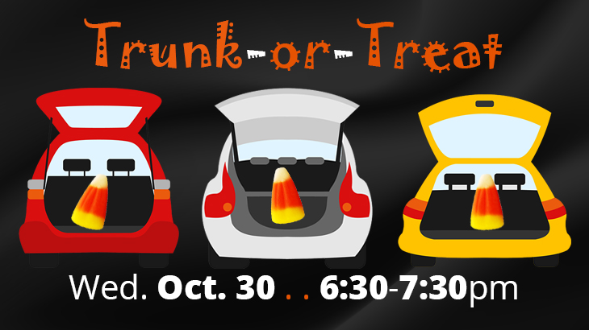Volunteer Sign-Up

Bethesda Lutheran Trunk-Or-Treat will be held on Wednesday, October 30th. The event will run from 6:30-7:30 pm. While the trunk decorating will begin at 6 pm, trunks will be judged at 7 pm. We are looking for volunteers to help with Set-Up, Kids’ Games, Serving warm drinks, and Clean-Up! Please email our Volunteer Coordinator, Miriam Chadima, at

mchadima@bethesdaames.org with any questions.

Set-Up
This shift would include blocking off the areas for the cars (trunks) and food truck, as well as setting up the games area, warm drinks table, and decorations and signs. We are looking for 6-8 people to help with this shift!
 | Name | Phone # | Email
5:30-6:30pm

Warm Drink Servers
These shifts need 2-3 people each and will include serving warm apple cider and hot cocoa to the participants of this year's Trunk-Or-Treat.
 | Name | Phone # | Email
6-6:30pm
6:30-7pm

7-7:30pm

Kids’ Areas
Each of these shifts needs 2-3 people to supervise the games area as there will be quite a few kids at this great event, and we want to keep them all safe!
 | Name | Phone # | Email
6-6:30pm
6:30-7pm

7-7:30pm

Clean-Up
This will include cleaning up the decorations and signs, drinks table, the trunks area, and taking the games from the youth area back into the church. We are looking for 6-8 people for this shift!
 | Name | Phone # | Email
7:30-8:15pm

